IFSM 432 Phase 2 Draft Plan (Group) Assignment

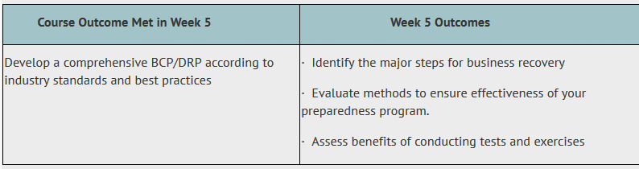
This is the second assignment of the phased group activity. The objective is to develop a draft BC/DR Plan according to researched industry standards and best practices.
Please use the detailed template provided as a separate attachment as an outline. Each group will complete all components of the assignment by the due date indicated in the syllabus schedule. Since this is a draft, you may only have some preliminary data in several sections. This is fine with the expectations that you will be maturing these sections. However, please strive to arrive at some preliminary information for each section.
There are five primary (or high level) sections to this draft plan that is detailed in the rubric:
- Draft plan purpose and invoking the plan (sections 1-11 in template)
- Response Scenarios (to map to risk area of your 1st group assignment) – Sections 12-20 in template
- Draft plan review and maintenance, diagrams and plan checklist (Sections 13-15 in template)
- Incident notification, COAs, and damage assessment (Sections 16-19 in template)
- Business recovery phase & Appendix (Sections 20-21 in template with Appendix)
Please complete all areas of the plan realizing that you will be maturing these sections as you proceed through the course. Always keep in mind the business scenario (NewOptMarketing) and your group risk assessment exercise to complete the sections of the plan. You can tailor each of the sections as you deem appropriate.
Important: Because this is a draft plan, you need not provide graphics (i.e., charts, measures) or references. However, you do need to provide at least a preliminary outline of your flow diagrams for Section 14. These are not expected to be mature at this point, but there should be a basic set of diagrams provided. Any additional graphics, charts or measures you wish to provide should be included with your final product in phase 4.
Weekly conference discussions will highlight concepts related to incident-response handing, disaster-recovery planning, and business continuity planning and processes.
Please stay aligned to the sections. However, you may include a discussion of later technologies that may reside in the template. One example is section 11 – Emergency management standards. The Tape retention policies may be dated (or still appropriate for use). You can refresh this section as appropriate to address how NewOptMarketing would address this policy.
Assignment Consideration:
- Please ensure that the draft plan incorporates the key elements identified in Phase 1 (except for graphs and references), complete with mitigation strategies demonstrating an understanding of course concepts, analysis and critical thinking.
- Ensure that the draft plan contains response scenarios that align well with identified risks.
- Ensure that your paper is well organized and presented in a professional format.
Grading Rubric:
The following grading rubric applies:
